Add Report Tab
Create A New Report
“Save As” Existing Report to Private Folder
Downloading/Export to Excel

Add Report Tab

- If there is no report tab, select the edit pencil icon on the far right
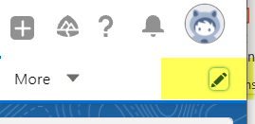
- Select the “Add More item button” and add “Reports”
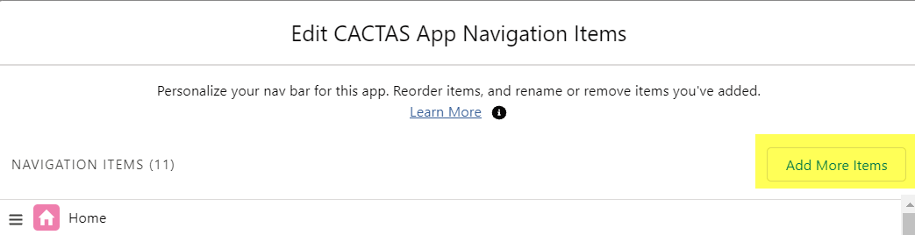

Creating a New Report

- From the Reports Tab, select “New Report”
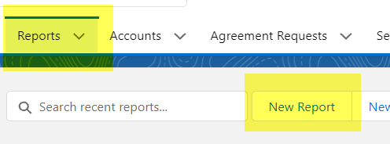

- Type “Agreements” in the Search Report Types. Select a report type that starts with Agreements, the “Agreement with” will include filter options also for the object after the “with”. For example. If you select “Agreement with Departments”, filters related to the department record will also available for selection

- Once a report type is select, started adding desired filters by selecting the filter icon.
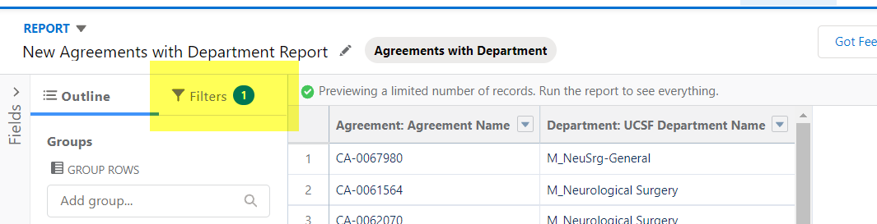

- Change default filters to:
  - “All Agreements”
  - “Agreement: Created Date” - select range as needed
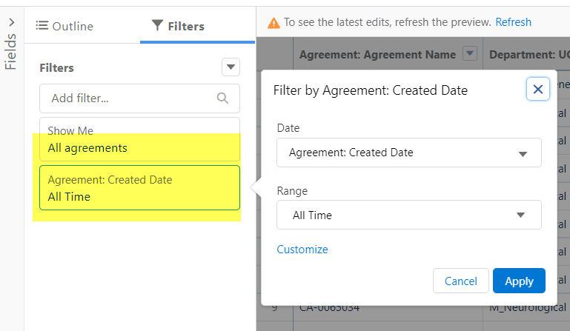

  - Add additional filers using the “Add filter...” field.
    - For example:
      - Status, Operator = Not equal to, Completed and Abandoned (this will give all records that are still open)
      - Department: Department Number. This would be below the “Agreement” Filter Options, under the “Department” Filter Options. Operator = Equal, and for value input the correct Depart Numbers. Multiple number can be listed with a comma between
        - To easily add multiple department numbers that are all subdepartments, use the Dept Report Filter on the bottom of the screen. Type in the Department names, click on “Build Filter” and it will provide the subdepartments that are in the levels below
        - Select copy
        - Paste into the filter field of the Report “value” fields
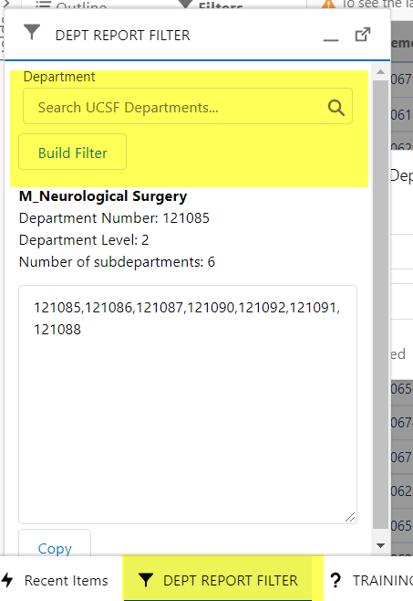
  - Once all desired filters are selected, select outline to pick fields to display. You can select “groups” or “columns”
    - Group Example: Select Principal Investigator for the group
    - Column Examples: Status, Sponsor, Primary Analyst Negotiator, Agreement Type, Action Type
  - After all filters and display options are selected, either save, run or save &run report

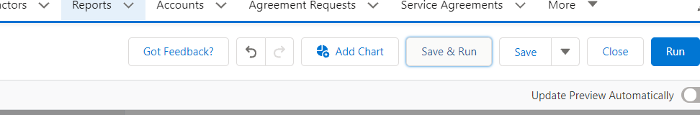

“Save As” Existing Report to Private Folder
Edit any existing report and save it into a Private folder. Please do not override existing reports in the public folders.
- Open an existing report and select “Save As” under the dropdown menu under Edit
- Select “All Folder” in the Save As pop-up window
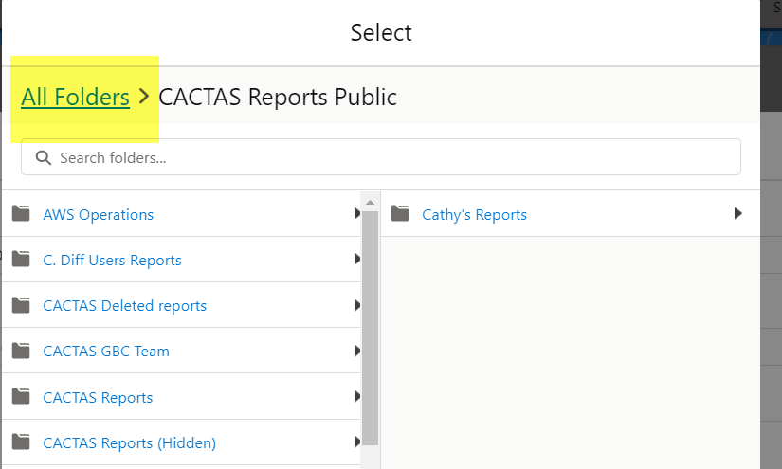

- Select “Private Reports”, then “Select Folders”. Please note, it is okay if “Nothing here yet” noted in the right panel. Report will be saved into “Private Reports”.
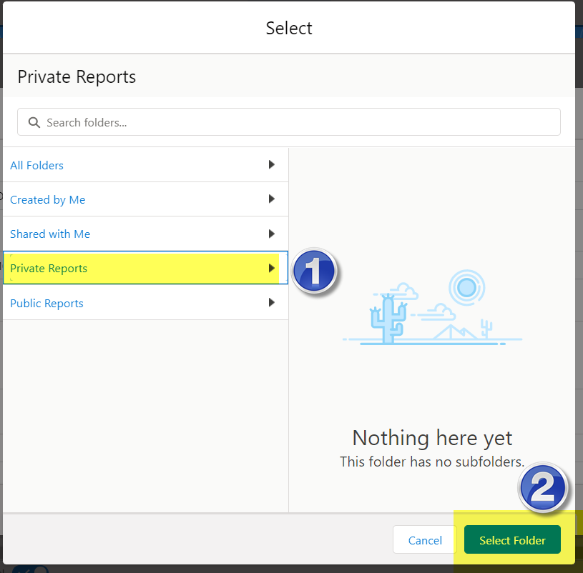

- To access Private Reports, go to Reports Tab and select from list on the left side of screen
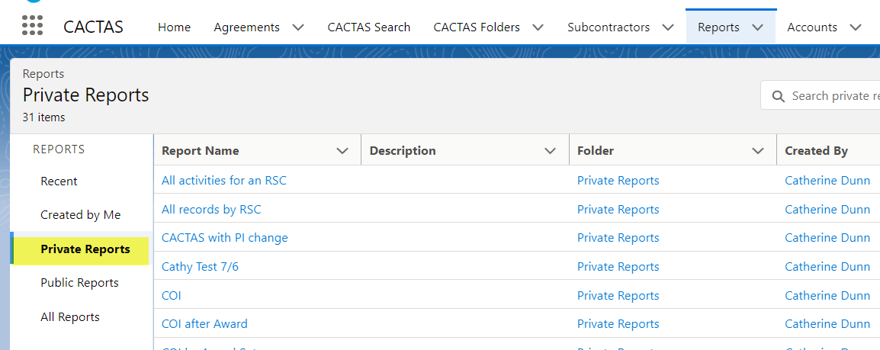

Download/Export to Excel
- Run a report
- Select “Export” from the dropdown menu on the far right

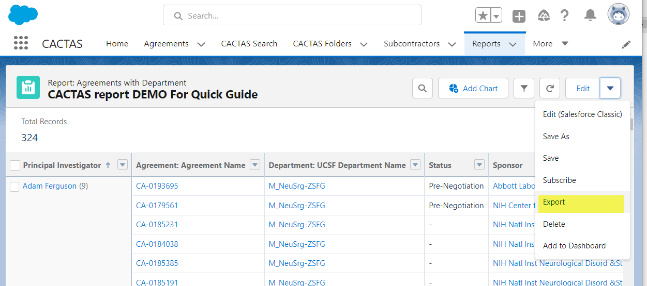

- Select Export view and click “export”. This will download the selected file type.
